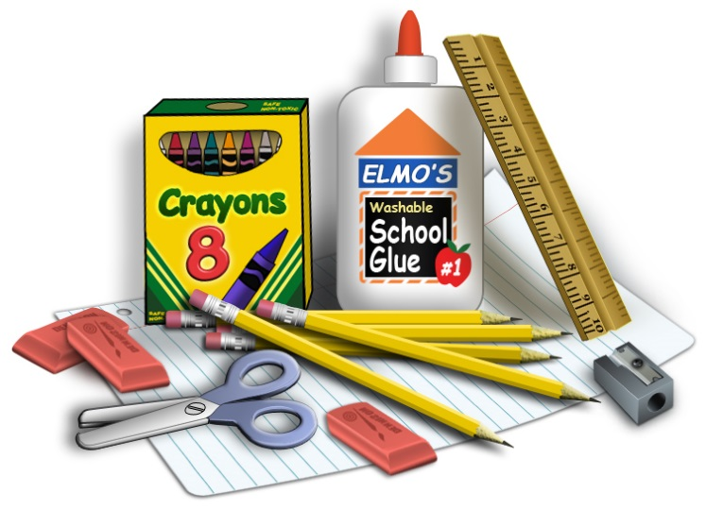
K4 Supply List 2021 – 2022

- 1 box of Kleenex

- 2 Rolls of paper towels

- 1 package of copy paper

- 1 package of cardstock

- 1 box of sidewalk chalk (we use at recess all year)

- 1 old button up shirt that can be used for a paint smock (One of Dad’s old shirts works great and covers the child completely)

- 2 large containers of Clorex/lysol wipes (will probably need more throughout the year)

- 1 hard plastic pencil box labeled with your child’s name

- Rainboots that will remain at school the entire year, labeled please. (The grass is usually wet during our morning recess time)

- 1 normal-sized back pack (no wheels please)

- 3 ring 1” white binder with clear outside pocket (to be used for morning sign-ins)

- 2” thick nap mat, crib sheet, and blanket for nap mat. Please label these items. (It is required by the state of TN for those that are staying until 3pm)

An additional $18.00 K4 supply fee will be billed to your account to cover addtitional supplies throughout the year. (paint, markers, cooking supplies, etc)

Art Class supplies for K4
K4 – 1 pack of white cardstock and one pack of Crayola washable markers

